**Impact of Area on Rates of Medical Readmission**

Gerald Burke

Western Governors University

D207: Exploratory Data Analysis

Dr. William Sewell

October 14, 2024

Contents

A. Real World Issue 3

A1. Research Question 3

Null Hypothesis 3

Alternative Hypothesis 3

A2. Stakeholders Benefits 3

A3. Relevant Data 3

B. Analysis 3

B1. T-test in Python 3

B2. Results 4

B3. Justification of Analysis Method 4

C. Univariate Statistics 4

Marital 4

Initial_Admin 6

Income 7

TotalCharge 9

D. Bivariate Statistics 10

Additional_charges vs. Gender 10

TotalCharge vs. Asthma 11

E. Implications 12

E1. Results of the Hypothesis Test 12

E2. Limitations of the analysis 12

E3. Proposed Action 12

F. Panopto Video 12

## A. Real World Issue

Medical readmissions are a significant problem in healthcare. The extent of the problem is that a hospital can be fined if readmissions rise above a target threshold. I have been tasked with examining the relationship between readmission rates and other factors to determine what can be done to reduce the rates of readmission and reduce the associated penalties.

### A1. Research Question

Does the area that a hospital serves have an impact on the rates of readmission?

#### Null Hypothesis

The area that the hospital serves does not have an impact on the rate of readmission.

#### Alternative Hypothesis

The area that the hospital serves does have an impact on the rate of readmission.

### A2. Stakeholders Benefits

The availability and quality of healthcare available in rural areas vs. urban or suburban areas is a question of major concern in the country today. For larger hospital chains like ours, we have some flexibility in terms of how and where we apply funding and resources. If we are able to determine a discrepancy in the rates of readmissions between areas, we have a path to changing outcomes for our patients and decreasing the financial and reputational ramifications of receiving large, recurring fines.

### A3. Relevant Data

**ReAdmis**

* Categorical
* Example: ‘Yes’
* ReAmis is defined as whether a patient was readmitted within a month of release

**Area**

* Categorical
* Example: Rural
* Area is defined as the type of area (rural, urban, suburban) the hospital serves

## B. Analysis

### B1. Chi-square Test in Python

Below is the code I wrote to perform the test:

#Chi-square test

import pandas as pd

import scipy.stats as stats

df = pd.read_csv('medical_clean.csv')

#Establish the alpha

alpha = 0.05

#Create the contingency table

contingency_table = pd.crosstab(df['ReAdmis'], df['Area'])

#Print the contingency table

print(contingency_table)

#Perform the test

chi2, p, dof, expected = stats.chi2_contingency(contingency_table)

#Print the results

print("Chi-square:", chi2)

print("P-value:", p)

print("The finding is significant" if p < alpha else "The finding is not significant")

### B2. Results

Chi-square: 0.7133125620168337

P-value: 0.7000130641731285

The finding is not significant

### B3. Justification of Analysis Method

Given the analysis is regarding two categorical variables, I opted to use a chi-square test.

I opted to perform the test in Python, primarily due to my familiarity with the language. I leveraged the SciPy Library to perform the test.

I tested with an alpha of 0.05 as it fit standard definitions of certainty.

## C. Univariate Statistics

#### Marital

The code I wrote to analyze the Marital variable is:

#Print relevant information about the variable

print('++++==== Begin ====++++\n')

print('++++==== Description of Marriage ====++++\n')

print(df['Marital'].describe())

print('++++==== Unique Values in Marriage ====++++\n')

print(df['Marital'].unique())

print('++++==== Counts of Values in Marriage ====++++\n')

print(df['Marital'].value_counts())

print('++++==== Percentages of Values in Marriage ====++++\n')

print(np.round(df['Marital'].value_counts() / df['Marital'].count() * 100, 2))

print('++++==== End ====++++\n')

#https://matplotlib.org/stable/gallery/pie_and_polar_charts/pie_features.html

fig, ax = plt.subplots()

ax.pie(df['Marital'].value_counts(), labels=df['Marital'].unique(), autopct='%1.1f%%')

plt.show()

The results of the report are:

++++==== Begin ====++++

++++==== Description of Marriage ====++++

count 10000

unique 5

top Widowed

freq 2045

Name: Marital, dtype: object

++++==== Unique Values in Marriage ====++++

['Divorced' 'Married' 'Widowed' 'Never Married' 'Separated']

++++==== Counts of Values in Marriage ====++++

Marital

Widowed 2045

Married 2023

Separated 1987

Never Married 1984

Divorced 1961

Name: count, dtype: int64

++++==== Percentages of Values in Marriage ====++++

Marital

Widowed 20.45

Married 20.23

Separated 19.87

Never Married 19.84

Divorced 19.61

Name: count, dtype: float64

++++==== End ====++++

The graph generated is:

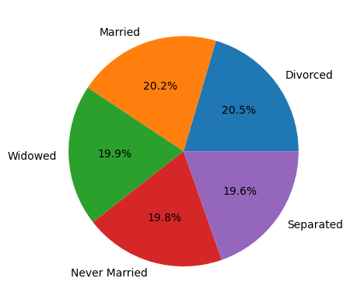

Marital is a categorical variable featuring 5 unique values: Widowed, Married, Separated, Never Married, and Divorced. Of these values, Widowed is the most commonly occurring 20.45% in all values with a count of 2,045. The percentage distribution of all values is within roughly 1% of one another, each hovering around 20%.

#### Initial_Admin

The code I wrote to analyze the Initial_admin variable is:

#Print relevant information about the variable

print('++++==== Begin ====++++\n')

print('++++==== Description of Initial_admin ====++++\n')

print(df['Initial_admin'].describe())

print('++++==== Unique Values in Initial_admin ====++++\n')

print(df['Initial_admin'].unique())

print('++++==== Counts of Values in Initial_admin ====++++\n')

print(df['Initial_admin'].value_counts())

print('++++==== Percentages of Values in Initial_admin ====++++\n')

print(np.round(df['Initial_admin'].value_counts() / df['Initial_admin'].count() * 100, 2))

print('++++==== End ====++++\n')

#https://matplotlib.org/stable/gallery/lines_bars_and_markers/bar_colors.html

fig, ax = plt.subplots()

ax.bar(df['Initial_admin'].unique(), df['Initial_admin'].value_counts(), label=df['Initial_admin'].unique)

ax.set_xlabel('Initial Admission Type')

ax.set_ylabel('Occurrences')

ax.set_title('Admission Types by Occurrence')

plt.show()

The results were:

++++==== Begin ====++++

++++==== Description of Initial_admin ====++++

count 10000

unique 3

top Emergency Admission

freq 5060

Name: Initial_admin, dtype: object

++++==== Unique Values in Initial_admin ====++++

['Emergency Admission' 'Elective Admission' 'Observation Admission']

++++==== Counts of Values in Initial_admin ====++++

Initial_admin

Emergency Admission 5060

Elective Admission 2504

Observation Admission 2436

Name: count, dtype: int64

++++==== Percentages of Values in Initial_admin ====++++

Initial_admin

Emergency Admission 50.60

Elective Admission 25.04

Observation Admission 24.36

Name: count, dtype: float64

++++==== End ====++++

The graph generated was:

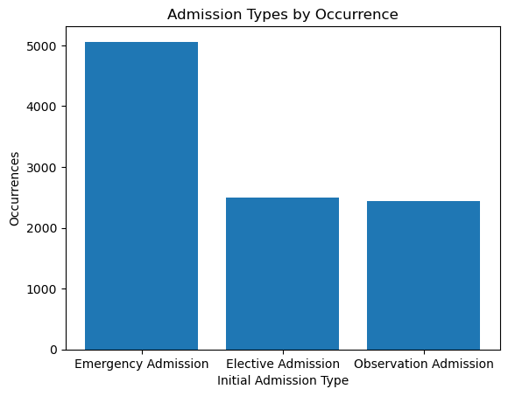

Admission_type is a categorical variable represented by 3 unique values: Emergency Admission, Elective Admission, and Observation Admission. Emergency Admission is by far the most common, representing more than half of all values with a count of 5,060. The other two values fell within 1% of one another, with each hovering around 25%.

#### Income

Below is the code I used to generate my analysis of Income:

print('++++==== Begin ====++++\n')

print('++++==== Description of Income ====++++\n')

print(df['Income'].describe())

print('++++==== Median of Income ====++++\n')

print(f'Median: {df['Income'].median()}')

print('++++==== End ====++++\n')

plt.hist(df['Income'])

plt.title('Income')

plt.show()

These are the results of the report:

++++==== Begin ====++++

++++==== Description of Income ====++++

count 10000.000000

mean 40490.495160

std 28521.153293

min 154.080000

25% 19598.775000

50% 33768.420000

75% 54296.402500

max 207249.100000

Name: Income, dtype: float64

++++==== Median of Income ====++++

Median: 33768.42

++++==== End ====++++

This is the graph generated:

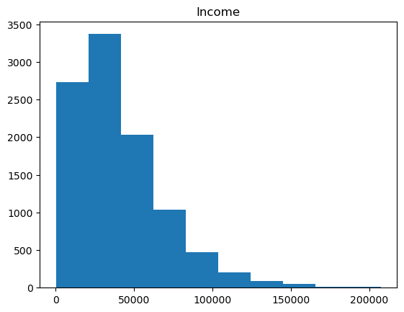

Income is a continuous variable with a mean of 40,490.50 and a median of 33,768.42. The interquartile range is 34,697.62. Given that the median is much lower than the mean, I was able to infer that the distribution was skewed right. The histogram generated confirmed this inference visually.

#### TotalCharge

The code I used to generate the report is below:

print('++++==== Begin ====++++\n')

print('++++==== Description of TotalCharge ====++++\n')

print(df['TotalCharge'].describe())

print('++++==== Median of TotalCharge ====++++\n')

print(f'Median: {df['TotalCharge'].median()}')

print('++++==== End ====++++\n')

plt.hist(df['TotalCharge'])

plt.title('TotalCharge')

plt.show()

The results of the report:

++++==== Begin ====++++

++++==== Description of TotalCharge ====++++

count 10000.000000

mean 5312.172769

std 2180.393838

min 1938.312067

25% 3179.374015

50% 5213.952000

75% 7459.699750

max 9180.728000

Name: TotalCharge, dtype: float64

++++==== Median of TotalCharge ====++++

Median: 5213.952

++++==== End ====++++

The graph generated:

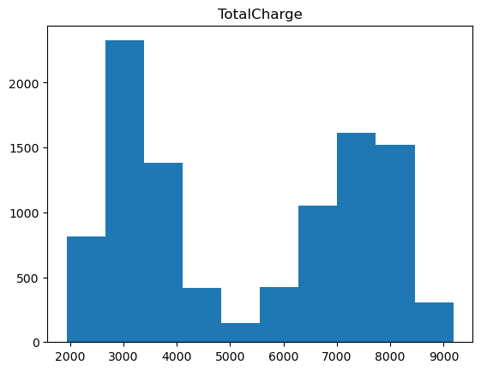

TotalCharge is a continuous variable with a mean of 5,312.17 and a median of 5,213.95. The interquartile range is 4,280.33. Given the closeness of the mean and median, I was anticipating a normal or uniform distribution. Visual analysis revealed two distinct ‘peaks’ in the data, signifying a bi-modal distribution.

## D. Bivariate Statistics

#### Additional_charges vs. Gender

The code I wrote to generate the report:

sns.boxplot(data=df, x='Gender', y='Additional_charges')

plt.title('Relationship of Additional Charges by Gender')

plt.show()

#Group by Asthma and calculate stats for TotalCharge

gender = df.groupby('Gender').agg(

Mean=('Additional_charges', 'mean'),

Median=('Additional_charges', 'median'),

Max=('Additional_charges', 'max'),

Min=('Additional_charges', 'min'),

IQR=('Additional_charges', calculate_iqr)

).reset_index()

print(gender)

The results of the report:

Gender Mean Median Max Min IQR

0 Female 12896.066069 11615.191865 30566.07 3139.049369 7511.782573

1 Male 12953.426237 11540.609295 30466.93 3125.703000 7819.419063

2 Nonbinary 13415.374018 11984.095000 29626.42 3369.832673 8413.311500

The generated graph:

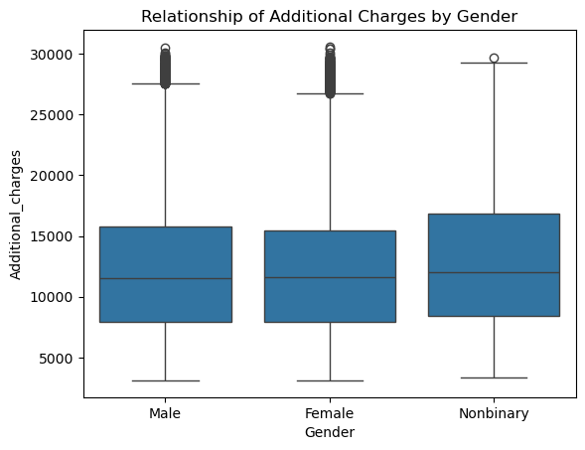

There appears to be correlation between the values of Gender(Nonbinary) and the other values in the set. The mean, median, min, and IQR of Gender(Nonbinary) are all higher than those of Gender(Male) or Gender(Female). The only exception is max, which is high than both Gender(Male) and Gender(Female). This is likely due to the high occurrence of outliers in those categories, compared to the relatively few in Gender(Nonbinary).

#### TotalCharge vs. Asthma

The code I wrote to generate the report:

sns.boxplot(data=df, x='Asthma', y='TotalCharge')

plt.title('Relationship of TotalCharge by Asthma')

plt.show()

#Group by Asthma and calculate stats for TotalCharge

asthma = df.groupby('Asthma').agg(

Mean=('TotalCharge', 'mean'),

Median=('TotalCharge', 'median'),

Max=('TotalCharge', 'max'),

Min=('TotalCharge', 'min'),

IQR=('TotalCharge', calculate_iqr)

).reset_index()

print(asthma)

The results of the report:

Asthma Mean Median Max Min IQR

0 No 5332.051476 5428.338000 9180.728 1938.312067 4270.372278

1 Yes 5263.338351 4568.911956 9169.248 2022.650007 4313.228213

The generated graph:

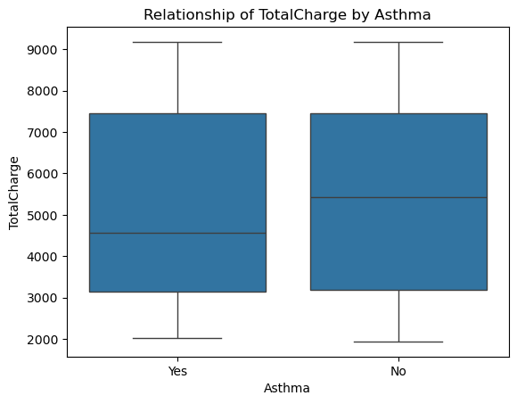

The two categories, Asthma(Yes, No), appear to have an even distribution of values across the range of TotalCharge. The exception being the median of Asthma(No) seems to be significantly higher than Asthma(Yes). Given my earlier analysis of TotalCharge, I’m led to believe this is due to the bi-modal distribution of the variable itself.

## E. Implications

### E1. Results of the Hypothesis Test

In the analysis, I achieved this result:

Chi-square: 0.7133125620168337

P-value: 0.7000130641731285

The finding is not significant

Given the established alpha of 0.05, the findings were not determined to be significant enough to reject the null hypothesis. The result is found that the area that a hospital serves does not impact the rate of readmissions.

### E2. Limitations of the analysis

The area collected within the survey data is based on unofficial census data. When and how this data was collected could present some potential for inaccuracy in results. The area classification is broad, and the parameters are not adequately described in the data dictionary. A larger sample size, more narrowly and explicitly defined categories, and data sources could improve both the quality of the data set and the analysis.

### E3. Proposed Action

Given the acceptance of the null hypothesis, I would advise both the analytics team and the stakeholders to explore new avenues in determining the factors that impact the rates of readmission. Perhaps testing readmission rates against the raw population numbers, rather than the obliquely defined area categories.

## F. Panopto Video

*See link for Panopto Video*

*Code included as D207_Task1.ipynb*

## G. Code References

The following were used to generate charts I was not familiar with.

<https://matplotlib.org/stable/gallery/pie_and_polar_charts/pie_features.html>

https://matplotlib.org/stable/gallery/lines_bars_and_markers/bar_colors.html